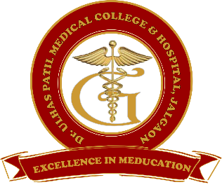 | Godavari Foundation’s  DR. ULHAS PATIL MEDICAL COLLEGE & HOSPITAL,  Recognized by Medical Council of India, Approved by Central Govt. of India, New Delhi,  Letter no. MCI-34(41)/2012-med./158127, dated 05/02/2013  Affiliated to Maharashtra University of Health Sciences, Nashik [College Code-1306]  Jalgaon-Bhusawal Road, NH-6, Jalgaon Kh, Tal. & Dist. Jalgaon 425309  Tel. No. (0257)2366657, 2366678 Fax No. 0257-2366648  Email ID : dupmcj@yahoo.in Web Site : www.dupmc.ac.in

6.4.1 Title:- Institutional strategies for mobilisation of funds and optimal utilisation of resources

Response:- Dr. Ulhas Patil Medical College and Hospital is a self-financed institute where mobilization of funds is obtained through collection of fees from UG and PG students, Hospital income and loans from bank. The funds are utilized under heads specified for expenditures and purchase equipment, Furniture and Books . Mobilization of funds is managed by Institute head (President).
Budgets are basically used for teaching and non-teaching salary, equipping library, laboratory, faculty salary, extension activities, building construction, student enrichment programme, Teaching learning practices, administrative expenses and social activities.
Resource mobilization policy is established. Details are given under each heading -
- Enhancement of Library facilities need to augment learning practices & accordingly requisite funds are utilized every year.
- Laboratory – for Equipments in central clinical laboratory, research laboratory, RTPCR laboratory, cath lab, fund is utilized
- Infrastructure – adequate income is mobilized for development and maintenance of infrastructure.
- Funds are utilized for student enrichment programme, workshop, sports and cultural activities.
- Adequate funds are allocated for effective learning practices that include orientation programme, training programme, interdisciplinary activities that ensure quality education.
- Some budgets are also reserved for day to day operational and administrative expenses.
- Budget also kept aside for social responsibilities to help community

Resources are received by following methods -
- Students fees (As per fee fixed by Fee Regulating Authority).
- Hospital income (investigations, surgeries, ICU, etc)
- Interest on fixed deposits and saving Bank Accounts.
- Term loans from bank and cash credit.
Every year a number of proposals are sent by the staff members to various works.
The college ensures the utilization of funds as per budgetary providences.
All expenses made are approved from college council. It is finally approved by the President
Main aim of resource mobilization and optimal utilization of resources are utilized for student and faculty development activities and infrastructure.

Chairman Dean
Dr. Ulhas Patil Medical College Dr. Ulhas Patil Medical College
& Hospital, Jalgaon Kh & Hospital, Jalgaon Kh

